Measuring Device for Standard B-type ultrasonic diagnosis equipment
Operating Instructions
KS107BD (L)
Tissue Mimicking Ultrasound Phantom
Institute of Acoustics，Chinese Academy of Sciences
Preface
Institute of Acoustics，Chinese Academy of Sciences
(1)Contact：NIU Fengqi， ZHU Chenggang
(2)Address：Institute of Acoustics，Chinese Academy of Sciences，21 Beisihuan West Road，Beijing 100190 ，China
(3)Tel：+86-10-82547731
(4)Fax：+86-10-82547730
(5)E-mail： niufengqi@163.com，zhuchenggang02@163.com

Table of Contents
PREFACE 1
STRUCTURE OF THE KS107BD (L) ULTRASOUND PHANTOM 2
PARAMETER 2
EXTRENAL STRUCTURE 2
STANDARD MATERIAL 2
NYLON TARGET LINE SYSTEM 2
OPERATING MENU 4
WARRANTY AND MAINTENANCE 9
PERIOD OF VALIDITY 9
WARRANTY PERIOD 9
REPAIR SERVICE 9
DAILY MAINTENANCE 9
LIQUID MAINTENANCE REQUIREMENTS 10
POUR CONCRETE OPERATION MAINTENANCE 11
GAS PURGING UNDER THE ASCOUSTIC WINDOEW 11

PREFACE
In clinic, the doctor is according to the ultrasound scanning the information provided by the ultrasonography diagnosis is made, so the image quality is regarded as a success for B-MODE image to exceed the quality of the products and judging the validity of the work of the primary factor. According to the international consensus, the image quality of technical indicators (i.e., performance) including dead zone, detecting depth and vertical to the resolution, horizontal to the resolution, beam slice thickness, contrast resolution and display and measurement of geometric error, etc. Tissue Mimicking Ultrasound Phantom can test these parameters. Ultrasound Phantom filled imitation body standard material (Ultrasonically Tissue-Mimicking Material) and embedded in the various test targets as well as acoustic window, shell, Indicative passive testing device consisting of a decorative Panel. It is in line with national standards GB10152-2009 requirements.

STRUCTURE OF THE KS107BD (L) ULTRASOUND PHANTOM
Applicable to the working frequency between 1-5 MHZ ultrasound equipment performance testing

PARAMETER
(1) TM material sound velocity: 1540±10m/s (23±3℃)
(2) TM material slope of the attenuation coefficient: 0.70±0.05dB/cm/MHz (23±3℃)
(3) Nylon target line diameter：0.3±0.05mm
(4) Nylon target location tolerance：±0.1mm

EXTRENAL STRUCTURE
Walls and bottom assembled by organic glass processing, open two, there are two of 36 mm diameter round hole in the floor. And cover 1 mm thick rubber, for maintenance of liquid injection. Outside the four walls and decorative plastic film panel surface have instructions. End face seal at 60 microns thick polyester film with silent window. The top 10 mm deep sink, detect even with water as the coupling agent is not lost. It is covered with 3 mm plate, in order to protect the sound window when not in use.

STANDARD MATERIAL
Filled standard Ultrasonically Tissue-Mimicking Material.

NYLON TARGET LINE SYSTEM
Nylon line buried in TM material embedded group of target 8, its distribution is shown in Figure 1.
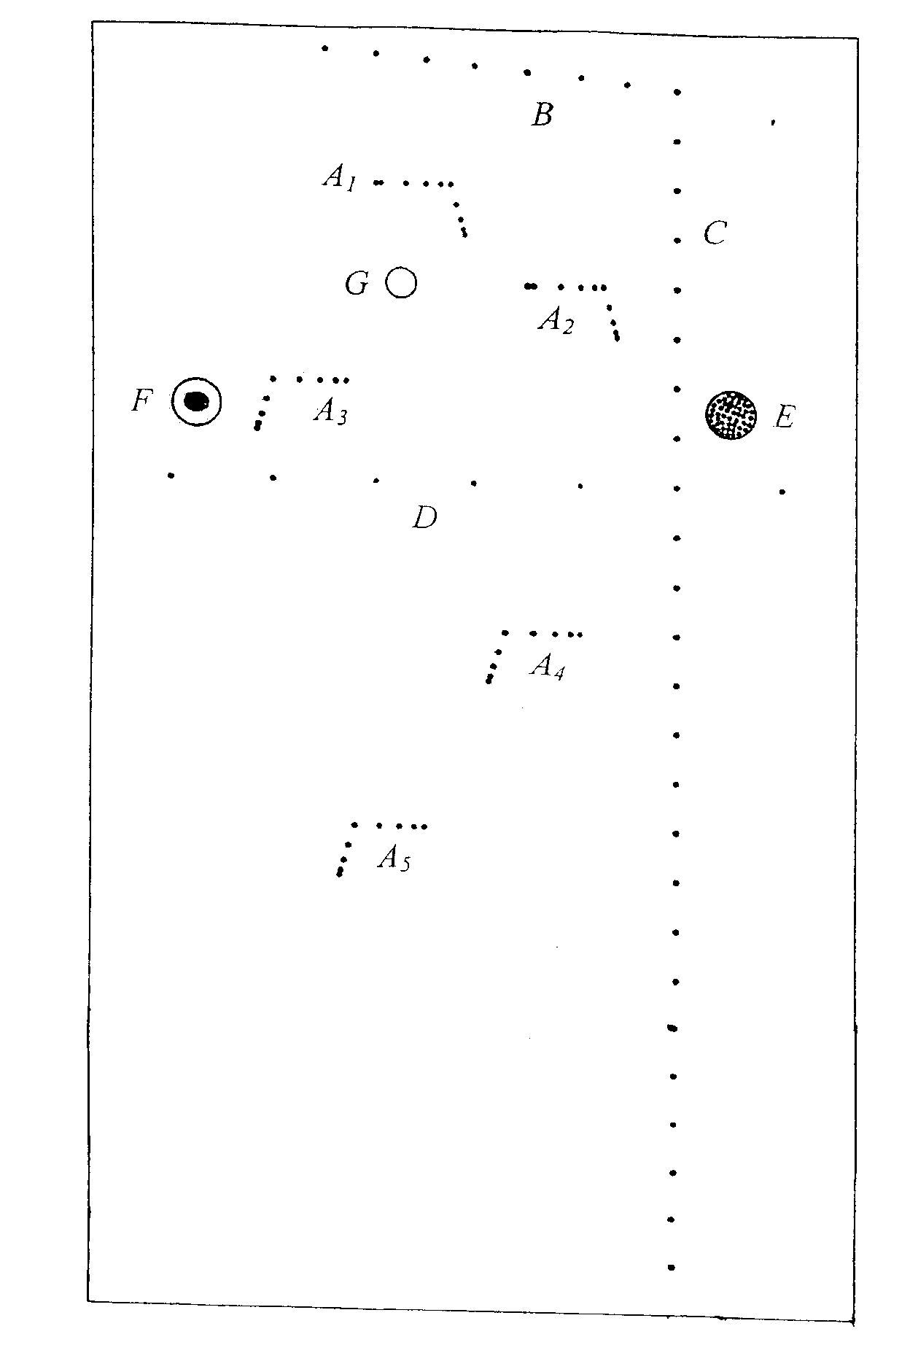
Figure 1
A1---A5: horizontal and Vertical Resolution Target Group
B: Dead Zone
C: Vertical Target Group
D: Lateral Target Group
E: Imitation of the Tumor
F: Imitation Capsule (10 mm) in diameter and stones
G: Imitation capsule (6 mm in diameter
- A1─A5: Resolution of target groups.
Lateral branches, respectively from the window 30, 50, 70, 120 and 160mm, A1─A2 Two groups of two adjacent targets in turn, the horizontal distance from the center line to 1, 5, 4, 3, 2 mm. A3─A5 Three groups of order in 5, 4, 3, 2mm. Vertical branch line vertically through the centers of two adjacent target line distance, respectively 4, 3, 2, 1 mm.
- B：Dead zone of target groups
Adjacent target line Center at a lateral distance of 10mm. The distance to window, is respectively 10, 9, 8, 7, 6, 5, 4, 3 mm.
- C：Vertical target group
Targets includes line 25, two adjacent line center distance is 10 mm
- D: Lateral target group
Targets includes line 7, two adjacent line center distance is 20 mm
- Simulation of lesions
  - E：
Tumor-like, between 70-80 mm in depth, cylindrical, 10 mm in diameter, column axis parallel to the target line.
  - F：Imitation cyst and stones
Cyst-like cylindrical shape, 10 mm in diameter, between 70-80 mm in depth, the axial parallel to the target line. Imitation stones of irregular shape, is located in the waist of cyst, maximum size of about 4 ─ 6 mm.
  - G：Imitation of cyst
cylindrical, 6 mm in diameter, column axis parallel to the target line, between 47-53 mm in depth.

OPERATING MENU
- Remove the cover plate and protect with cushions.
- Pour into the proper amount of distilled water in a flume (to ensure that the probe and the sound window, for coupling degree between should not be commonly full of sink) or water-based gel type medical ultrasonic coupling agent.
- According to the prescribed procedures to open the instrument being measured.
- The probe will be test equipment by the coupling medium in phantom window, and make the target with a plane perpendicular to the beam scanning. Write down model, scanning probe and working frequency, the convex array probe should also write down the radius of curvature.
- (Maximum) Detecting Depth Measurement
  - Aim the probe to vertical target group, the mechanical fan sweep (including ring array), convex array, phased array probe, and aim at the target group of the top should be defined by the center.
  - Improve the total gain, adjustable on STC, improve gain far field, the near-field gain to appropriate.
  - Improve contrast (with adjustable, similarly hereinafter) to appropriate levels.
  - Improve the brightness (of adjustable, hereinafter the same), but no defocusing and halo in the screen in the limit.
  - The focus adjustment (with adjustable, similarly hereinafter) buy far field focus or more paragraphs, full depth and focus.
  - Through the above regulation, obtain the maximum depth of test instrument can achieve uniform within the scope of the picture.
  - Read observed the maximum depth of target point depth (mm), is the (maximum) detection depth.
- Dead Zone Measurement
- Aim the probe to dead zone target group, if can't cover all at a time, the translational probe section observation.
- Decrease the total gain, near-field gain and brightness, abate TM materials backscattering point, make the target image is clearly visible.
- Focus on near-field.
- Read the minimum depth of the target line depth (mm) can be observed, where the dead zone is.
- Lateral Resolution Measurement (threshold)
- Aim the probe to a lateral resolution target group or axis lateral branch of lateral resolution target group.
- Reduce the total gain, according to the target group of weakening the TGC in depth (or on STC, DGC).
- Reduce brightness.
- Maintaining high contrast.
- The focus adjustment on or close to the target group of the depth or checked at multiple stage, full depth and focus.
- Through the above adjustment, near the measured depth deeper into the backscattering light spot, TM materials and keep the target line image visible.
- translation probe, a small scale and slight pitching, read between the minimum target line clearance (mm), is the depth of lateral resolution (threshold)
- Axial( Vertical) Resolution Measurement (threshold)
- The axial resolution of target aim the probe a group or shaft axial( Vertical) branch of lateral resolution target group.
- Checked instrument regulation with lateral resolution measurement (threshold), in the test after a certain depth of lateral resolution, immediate detection with the depth of the axial( Vertical) resolution.
- Read can distinguish the minimum target line clearance (mm), is the depth of the axial resolution.
- Longitudinal geometric position (accuracy) of error of measurement
- Aim the probe to vertical target group.
- The total gain, the TGC (or on STC, DGC), contrast and brightness are adjustable to moderate.
- The focus adjustment more segments or a state of full depth of focus.
- Through the adjustment, the weaker the TM backscattering light material has a clear target group of longitudinal image background.
- The image is frozen, the effective detection depth range, measured with electronic vernier in turn every 20 mm apart two target line image center distance (mm), with 20 mm deviation at most to get relative error (%), is the longitudinal geometric position (accuracy) of error.
- Transverse Geometry (accuracy) of Error of Measurement
- Aim the probe to lateral target group.
- The total gain, the TGC (or on STC, DGC), contrast, brightness to moderate.
- The focus adjustment at or near the target group of the depth or lateral segment, a state of full depth of focus.
- The image is frozen, measured with electronic cursor in two target line image center distance (mm), with 20 mm deviation at most to get relative error (%), is the transverse geometry (accuracy) of error.
- Observation simulating lesions
- Aim the probe to interest in simulating lesions.
- The control gain, the TGC (STC, DGC), contrast, brightness to the best state.
- Focus adjustment at or near the lesions in depth of focus or more paragraphs, and a state of full depth of focus.
- Through the adjustment, similar to the clinical diagnosis of material backscattering of TM image, the image on the background of this observation simulating lesions, its features are:
  - Cyst: for there is no spot black hole, clinically known as "no echo area"; Behind the backscattering light on both sides of the image brighter than with depth, known as the "enhanced" behind the clinically. Electronic vernier if necessary measuring the longitudinal or transverse diameter (mm), and compared with design value, calculates the relative error (%).
  - Stones: the image itself for the strong reflection light, rear back scattering light was lost in a dark belt, referred to as the "rear acoustic shadow" clinically.
  - Tumor: the image for background more thick, more than the brightest spot area, contour assumes the circular.
- When finished measurements, pour out and wipe clean distilled water; If gel type coupling agent, should be after wipe with clean water, do not make hard the corners on the surface acoustic window or sink. Put away the sponge, cover plate.

WARRANTY AND MAINTENANCE

PERIOD OF VALIDITY
Because of the special structure principle of ultrasound phantom is according to the valid management approach. KS series product is valid for three years. After three years, the Phantom should be test by acoustic measurement test station, Chinese academy of sciences. If the performance testing is gotten through, it can continue to use.

WARRANTY PERIOD
KS series ultrasound phantom warranty period is three year. If the user in violation of this specification in the carrying, storage, use, or demolition, alteration and damage caused by itself, shall not be under warranty.

REPAIR SERVICE
- Change the sound window: if the sound window accidentally broken or long with torn, users should immediately use tape will break the seal, don't make the phantom in liquid by the crevasse is lost, and send me the repair in time. We can change for the new sound window, appropriate fees.
- Repair the TM materials: if the material surface TM serious damage caused by misuse, but still below part is normal, we can eliminate damage part, back filling, and appropriate fees.

DAILY MAINTENANCE
- Within the phantom of polymer gel type TM material freezing point of 0 ℃, melting point is 78 ℃. Ice, or melting means phantom die completely scrapped, so do not freeze or baking. The best storage temperature for 10 to 35 ℃.
- Do not drop, bumping, or force required. In addition to the note fluid maintenance, should be upright, not upside down.
- The window is the weakest part; please do not contact with sharp edges, in case the prick the scratch. Should cover plate when not in use. The sponge inside the original placed in the tank (soft foam) pad do not discard, idle and phantom must be in place when carrying, transportation, in order to protect the window.
- Ultrasound phantom limited use water-based gel type coupling agent or distilled water, do not use oily preparations.
- Phantom if there is any dirt, can only use water-based detergent to clean, do not use gasoline, acetone, alcohol, such as organic solvents.

LIQUID MAINTENANCE REQUIREMENTS
- Necessity: as the core and the most critical part of ultrasonic phantom, TM materials contained within the liquid through the shell, acoustic window slowly evaporates, eventually leading to its performance variation, body die failure. Therefore, must be regularly injected fluid of proper maintenance. When the phantom sales, the liquid also provide.
- Maintenance cycle: in principle, liquid injection once every six months. Considering the differences of climate conditions in various regions, users can accumulate experience, proper control.
- The liquid injection rate: under the condition of maintenance in time, average number per milliliter. Injection fluid in place of the logo is: in the phantom upside down, the sink in the sea under the condition of the pads hold, filler sealing rubber floor after a flat or slightly subsidence, must not make its ballooning.
- Note: the materials needed by liquid maintenance fluid, cushions, 20 ml injection needles, 6 needles.

POUR CONCRETE OPERATION MAINTENANCE
- The phantom upside down, and there he put the rubber cushion tank inside the frame.
- Unscrew the retaining plate of two nuts, remove the retaining plate.
- Remove the embolism, packed needles, will maintain the liquid from the needle big injection, to half its capacity. Insert of embolism, and then put the needle upward, slow progress embolism to ward off the air.
- To insert needles at TM materials slotted into the rubber membrane, the needle 1-2 mm. Slow progress embolism, liquid injection, to rubber membrane is flat or slightly subsidence. If there is too much, should be pulled out. If a needle is rubber scurfy jams, application of thin steel dredge used again.
- Pull out the needle, and will maintain fluid back to the storage bottle not use up.
- Install the retaining plate, Rotary well nut.. Place the phantom back to normal.

GAS PURGING UNDER THE ASCOUSTIC WINDOEW
- Necessity: because the injection fluid maintenance or insufficient injection on time, there will be a small piece under acoustic diaphragm or a whole layer of gas, thus affect the normal use of the phantom. It must be removed
- The phantom upside down, and put the rubber cushion fill in the sink.
- According to the liquid injection method, through the bottom sealing rubber membrane to infuse 10 ml maintain fluid, until the sealing rubber membrane a slight bulge.
- Place the phantom side, and near the target group of longitudinal with English toward the side of the desktop.
- Remove the cushions, the visible under the membrane gas floating.
- Along the sound window film with a wet towel and gently rub on, make the gas concentrated on top.
- With the right hand bottom of the phantom appropriately brought, left with wet towel pushed has focused a little bit of gas, making it into the other side of TM material and shell cracks.
- Then phantom upside, mat placed inside the borders of the sink. Place the phantom desktop security against the wall, which lasted half a day or a day, requiring gas to move, under the plexiglass to the backplane (see).
- With finger tapping rubber membrane, make the gas into its bottom. Then take out gas with needles.

